**Subquery**

In SQL a Subquery can be simply defined as a query within another query.

You can place the Subquery in a number of SQL clauses: WHERE clause, HAVING clause, FROM clause. Subqueries can be used with SELECT, UPDATE, INSERT, DELETE statements along with expression operator. It could be equality operator or comparison operator such as =, >, =, <= and Like operator.

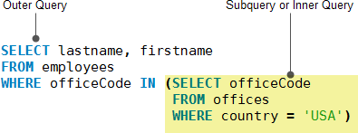

Example tables:

**Pets**

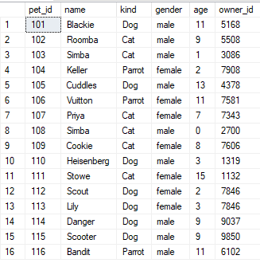

**Owners**

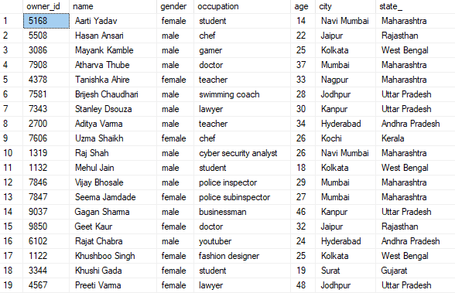

**Vet**

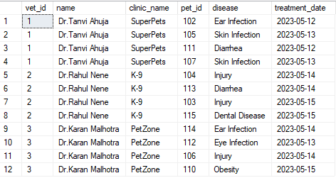

**Questions:**

1. **Give names and ID of pets who have been treated by a vet.**

Query:

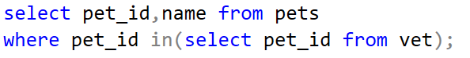

Result:

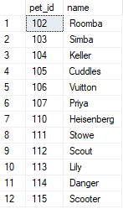

1. **Give names and occupation of owners who have a pet treated for ear or skin infection**

Query:

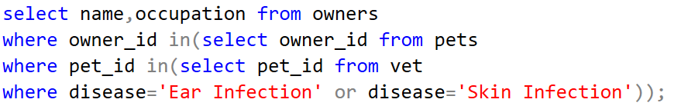

Result:

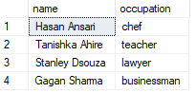

1. **Display name, kind and age of pets whose age is equal to average age of all pets.**

Query:

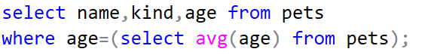

Result:

